**Project Design Phase-II**

**Data Flow Diagram & User Stories**

|  |  |
| --- | --- |
| Date | 17 November 2023 |
| Team ID | Team-592061 |
| Project Name | River Water Quality Forecasting |
| Maximum Marks | 4 Marks |

**Data Flow Diagrams:**

A Data Flow Diagram (DFD) is a traditional visual representation of the information flows within a system. A neat and clear DFD can depict the right amount of the system requirement graphically. It shows how data enters and leaves the system, what changes the information, and where data is stored.

Example: DFD Level 0 (Industry Standard)

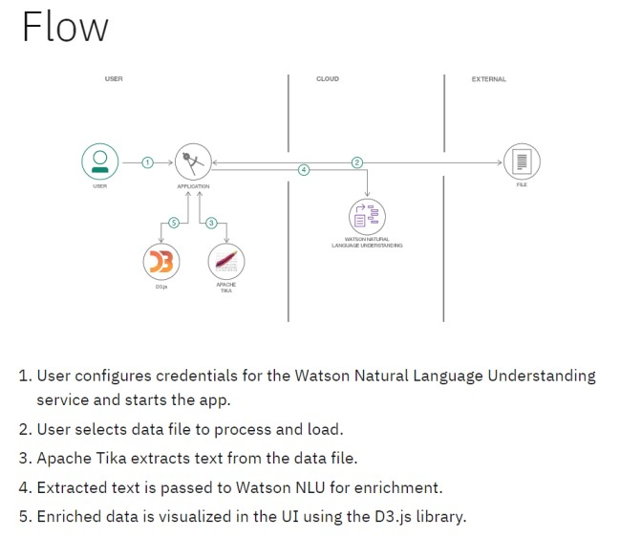 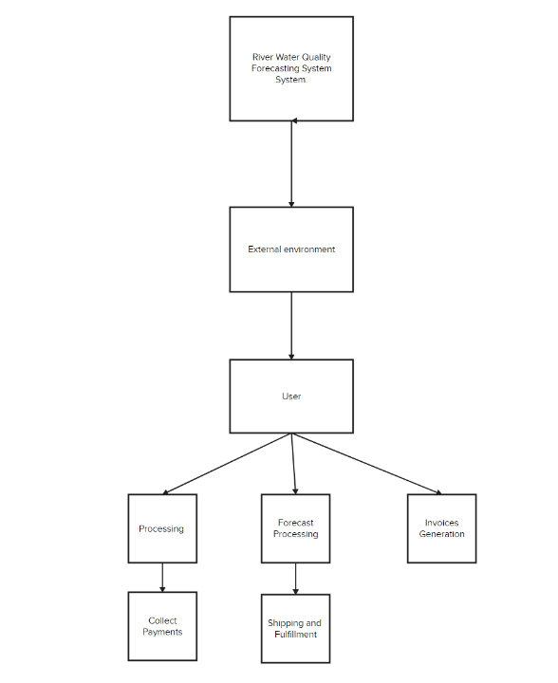

**User Stories**

Use the below template to list all the user stories for the product.

|  |  |  |  |  |  |  |
| --- | --- | --- | --- | --- | --- | --- |
| **User Type** | **Functional**  **Requirement (Epic)** | **User Story**  **Number** | **User Story / Task** | **Acceptance criteria** | **Priority** | **Release** |
| Customer  (Mobile user) | Registration | Vishnu | As a water quality analyst, I want to input historical water quality data for a specific river, so that the system can use it for forecasting. | The system should allow the user to input various water quality parameters (e.g., pH, turbidity, dissolved oxygen). <br> - The system should validate the input data for accuracy and completeness. | High | 1.0 |
|  |  | Harsha | As a river manager, I want to view a graphical representation of historical water quality trends, so that I can identify patterns and anomalies. | The system should generate a time-series graph showing changes in water quality parameters over a selected period. <br> - The graph should have options for zooming in/out and selecting specific parameters. | Medium | 1.0 |
|  |  | Nanda kishore | As a water quality analyst, I want the system to automatically detect and flag unusual water quality events, so that I can investigate and address potential issues. | The system should employ anomaly detection algorithms to identify deviations from normal water quality patterns. <br> - Users should receive notifications for flagged events. | High | 1.1 |
|  |  | Nithin | As a river manager, I want to receive daily water quality forecasts for the upcoming week, so that I can plan and respond to potential water quality issues. | The system should provide daily forecasts for key water quality parameters. <br> - Forecasts should include a confidence level or range. | High | 1.1 |
|  | Login | USN-5 | As a user, I can log into the application by entering email & password |  | High | Sprint-1 |
|  | Dashboard |  |  |  |  |  |
| Customer (Web user) |  |  |  |  |  |  |
| Customer Care Executive |  |  |  |  |  |  |
| Administrator |  |  |  |  |  |  |
|  |  |  |  |  |  |  |
|  |  |  |  |  |  |  |
|  |  |  |  |  |  |  |